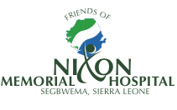

Friends of Nixon www.friendsofnixon.org Charity no. 1145455
C/O 11a Denbigh Road, London, W11 2SJ

The 11th Annual General Meeting of the
Friends of Nixon Memorial Hospital, Segbwema, Sierra Leone

Saturday 26th November 2022
at
Notting Hill Methodist Church, 240 Lancaster Road, London, W11 4AH

Proposed agenda

1230 – 1400 Arrival, Reception and Buffet Lunch

1400 – 1600 Meeting to include:

- Chairman’s welcome and Annual Report
- Financial Report
- Election of Officers
- Presentations
  - Nursing School
  - Mortuary
  - Fundraising

- Questions and discussion

Date for Diary – Next year’s AGM will be on Saturday 25th November 2023

