www.friendsofnixon.org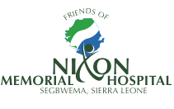 Charity no. 1145455

Friends of Nixon Covid-19 Response

Sierra Leone, and more specifically Kailahun district in which the Nixon memorial Hospital is sited, has not escaped the impact of the global coronavirus pandemic. Patients and staff have had to face consequences of both the disease itself and of lockdown measures put in place to combat its spread. In Segbwema where many people live day to day, restrictions in movement can increase the prevalence of food poverty. In response to a request from the hospital, Friends of Nixon has funded a Covid-19 support project to provide additional hand sanitizer and liquid soap for the hospital. We have also funded a package of food aid to ensure patients, vulnerable individuals and staff have access to appropriate nutrition during this time. Thankfully, the hospital has a level of surplus PPE equipment following the Ebola crisis. Currently this is being used together with procedures relating to infection prevention and control learnt during the Ebola epidemic. During this time, we will also continue our existing commitments to essential medicine funding, community health and staff training in order that the hospital maintains its vital role within Segbwema and the wider community.

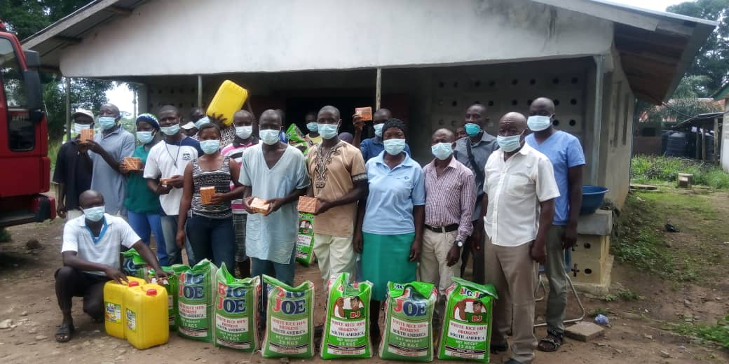
Nixon Staff
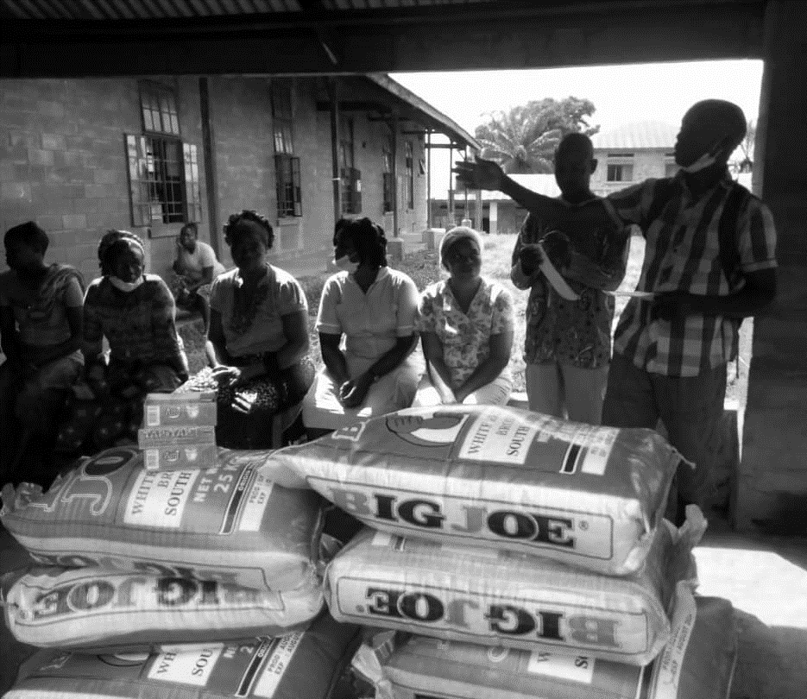
Food Aid being distributed to patients
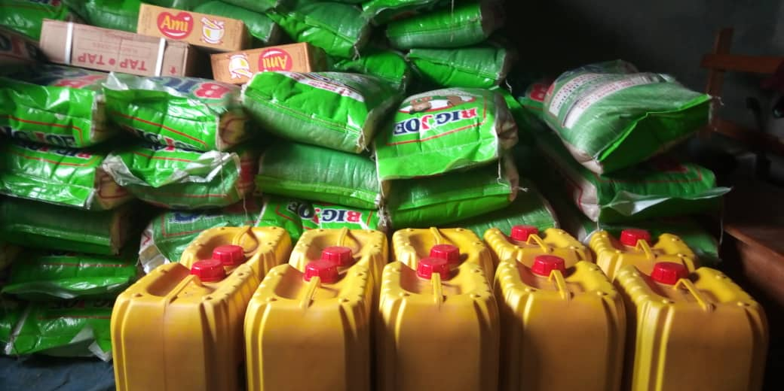
100 bags of 25kg rice, 10 containers of cooking oil and 3 cartons of Maggi were distributed
Dr Missa with some of the hand sanitizer and soap

