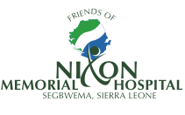

www.friendsofnixon.org Charity no. 1145455
c/o 11a Denbigh Road, London, W11 2SJ

You are warmly invited to

The 12th Annual General Meeting of the
Friends of Nixon Memorial Hospital, Segbwema, Sierra Leone

Saturday 25th November 2023

At

Notting Hill Methodist Church, 240 Lancaster Road, London, W11 4AH

Proposed agenda

1230 – 1400 Arrival, Reception and Buffet Lunch

1400 – 1600 Meeting

For further information or to confirm your attendance please email our Secretary Janna Burnie – janna141@hotmail.com

